Project Requirements

Joeseph Sande

CST-451 Capstone Project Requirements Document

Grand Canyon University

Instructor: Professor Mark Reha

Revision: Initial

Date: 16 October 2022

**ABSTRACT**

The Wakup9000 will be a digital clock that will keep track of appointments for the user, light up when it is time for set meetings, display the time on the digital clock, and display a message relating to what status the clock is in at that time. This device will be perfect for users who desire to keep a physical clock in their home offices to remind them when their appointments are. When the clock sets off an alarm, it will light up the LED lights on the board and display a message on the LCD Display screen for the user while flashing the time on the board while it still continues to move the clock’s time forward.

With FPGA technology at the team’s disposal, this is a perfect task for them to tackle. The hardware contains all of the features that this alarm clock requires and it is configurable in the field if the client were to want additional features in the future or for current features to be manipulated. This leads to a potential stream of revenue for the company in the future as we continue to make updates to the product and send our employees out for field operations to update purchased products for the clients. An example of a future addition to this product would be to create an outside application that can connect to the alarm clock to automatically update the product and sync up with the user’s calendar. For the Wakup9000’s current proposed features, the clock will conduct all of the required features of displaying a message to the user, displaying the time, allowing the user to utilize the various inputs to configure the clock settings and turn off the alarm, and flash LED lights when the alarm goes off.

|  |
| --- |
| History and Signoff Sheet |

**Change Record**

|  |  |  |
| --- | --- | --- |
| **Date** | **Author** | **Revision Notes** |
| 16-October-2022 | Joeseph Sande | Initial draft for review/discussion |
|  |  |  |
|  |  |  |

|  |
| --- |
| **Overall Instructor Feedback/Comments** |

|  |
| --- |
| **Overall Instructor Feedback/Comments** |

**Integrated Instructor Feedback into Project Documentation**

Yes  No

**TABLE OF CONTENTS**

Functional Requirements 4

Non-Functional Requirements 5

Technical Requirements 6

Logical System Design 7

User Interface Design 8

Reports Design 9

Functional Requirements

**Use Cases**

The Wakeup9000 will provide the ability for the user to configure the settings required to display the time and create alarms on the clock. Please see the attached CST_451_Requirements_JoesephSande.xls spread sheet for the complete list of user stories associated with this project.

Non-Functional Requirement

**Use Case**

A non-functional requirement for the Wakeup9000 relates to its general performance when balancing numerous operations without allowing the clock to fall off track with its time incrementation. Please see the attachedCST_451_Requirements_JoesephSande.xls spread sheet for the non-functional user story associated with this project.

Technical Requirements

**Tools and Technologies:**

|  |  |
| --- | --- |
| **Technology or Tool** | **Justification** |
| **ARM Eclipse IDE v.22.3** | **The development environment for creating the FPGA programs.** |
| **SD Memory Card Formatter v.5.0.2** | **To format an SD card for the clock.** |
| **Win32 Disk Imager v.1.0.0** | **To format the SD card to run Linux.** |
| **DE10-Standard Linux SD Card Image v.1.3.0** | **To run Linux on the clock.** |
| **DE10-Standard-UP-Linux v.1.3.0** | **To run Linux on the clock.** |
| **DE10-Standard FPGA Board** | **The main hardware being manipulated into a clock.** |
| **FileZilla v.3.60.2** | **Used in development to transfer files to the board.** |
| **PuTTY v.77** | **Used in development to test and run files on the board.** |
| **Cygwin v.3.3.6** | **Used in development to run Linux commands on Windows.** |
| **GDB v.7.4** | **Used for debugging in the development environment.** |
| **MinGW v.11.2.0** | **Used for the development environment for board communication through Windows OS.** |
| **Linaro toolchain v.4.8** | **Linux kernel, GNU Compiler Collection (GCC), QEMU, power management, graphics, and multimedia interface for ARM instructions.** |

Logical System Design

**Introduction**

The challenge being addressed with this project the Wakeup9000 is the ability to wake the heaviest sleeper from their naps and for the team to gain familiarity with FPGA products to implement more complex solutions to future problems. This project will be the team’s first interaction with imbedded systems, so this is a perfect challenge for them. The DE-10 Standard FPGA Board has every component required to create a functioning clock that will cover all of the required specifications of waking up a heavy sleeping individual. The necessary components that will be utilized to achieve this goal are the buttons, switches, lights, 7-segment display, and the LCD screen.

**Block Diagram of High-Level Solution**

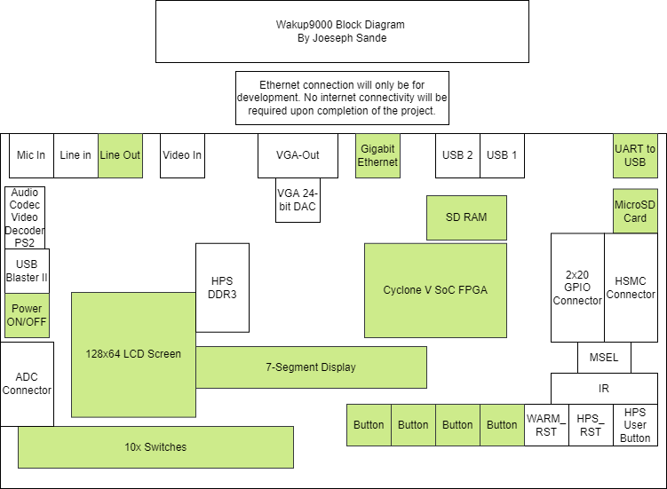

**Components Utilized:**

1. LCD Screen – will be utilized to display clock status messages to the user.
2. 10x switches – will be utilized to configure settings for the clock.
3. 4x buttons – will be utilized to configure settings for the clock.
4. LED lights – will light up when the alarm goes off.
5. 7-Segment Display – will be used to display the timer of the clock using a BCD decoder.
6. MicroSD Card Slot – will be used to hold the program files for the clock.
7. Gigabit Ethernet port – will be used to connect the clock to a computer for development using FileZilla data transfers.
8. UART to USB port – will be used to connect the board to a development environment.
9. USB Port – is optional for a WIFI adapter, but will not be used in this project.
10. Cyclone V SoC FPGA Processor- will be used to process the application.
11. SD RAM- will be used to process the application.

**High-Level Solution Description**

The solution to creating the Wakup9000 will incorporate the components within the board on the above diagram. This board runs on an ARM processor that will be programmed to incorporate the components listed above. This board will utilize its buttons and switches for providing the user with the ability to configure the board’s settings, to turn off, and to reset the alarm. The Cyclone V SoC FPGA Processor with process all of the requests being sent to the board. The 128x64 LCD Screen will display the messages for what the alarm is relating to for the user. The MicroSD Card slot will hold the MicroSD card that contains the Linux and program files for the board to operate. The 7-segment display will be where the time is shown on the board. The use of the Gigabit Ethernet or a WIFI adapter to a USB slot on the board is optional to provide internet capabilities for the board and will only be required for development purposes.

User Interface Design

Wireframe Diagram:

